
BACHELOR OF COMPUTER SCIENCE (SOFTWARE ENGINEERING)

COURSE NAME AND CODE:
CSE3023 – WEB-BASED APPLICATION DEVELOPMENT (K1)

LAB 1

SEMESTER II SESSION 2025/2026

PREPARED BY:
NAME: AINAA NADHIRAH BINTI ASMADI
MATRIC NUMBER: S75246

COURSE LECTURER:
DR. WAN NURAL JAWAHIR BINTI HJ WAN YUSSOF

LAB MODERATOR:
PN. WAN FATIN FATIHAH BINTI YAHYA

LAB 1

Task 6: Writing a Simple Java Servlet
HelloServlet.java File
Code:
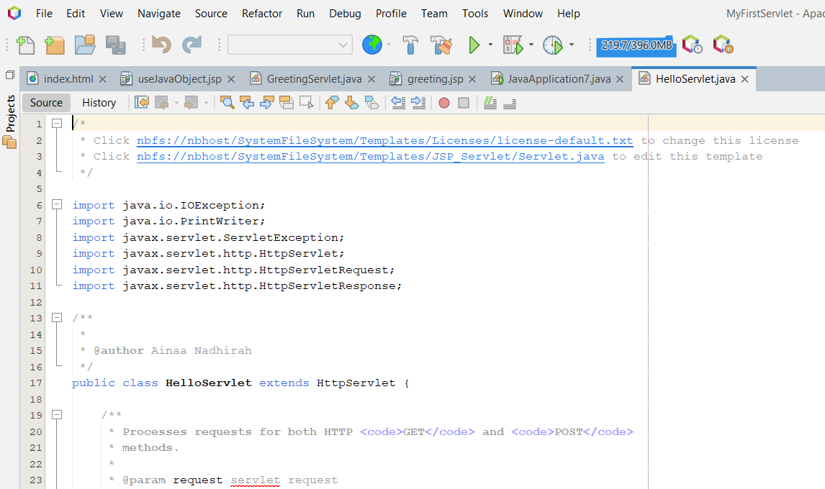

processRequest() method:
Code:
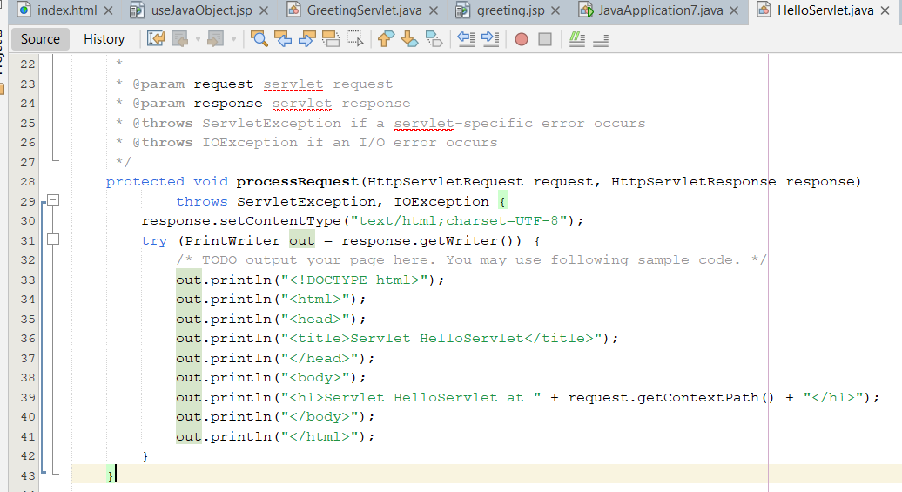

Result:
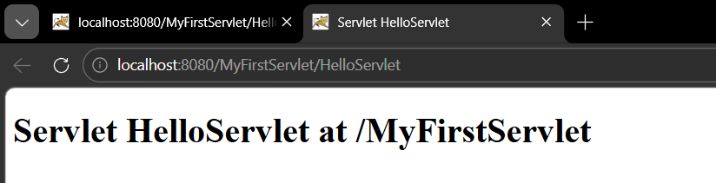

After modify processRequest() Method:
Code:
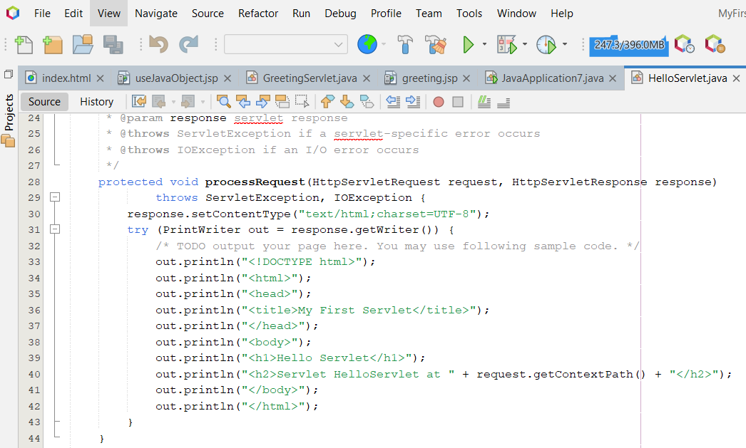

Result:
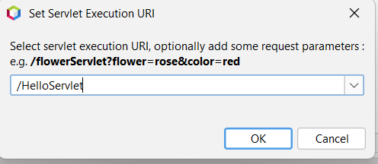

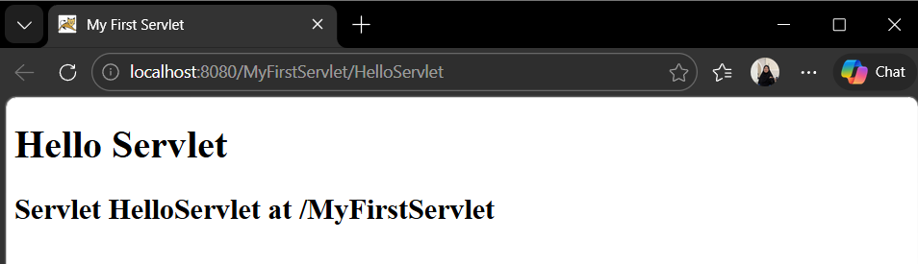

After modify the doGet() method:
Code:
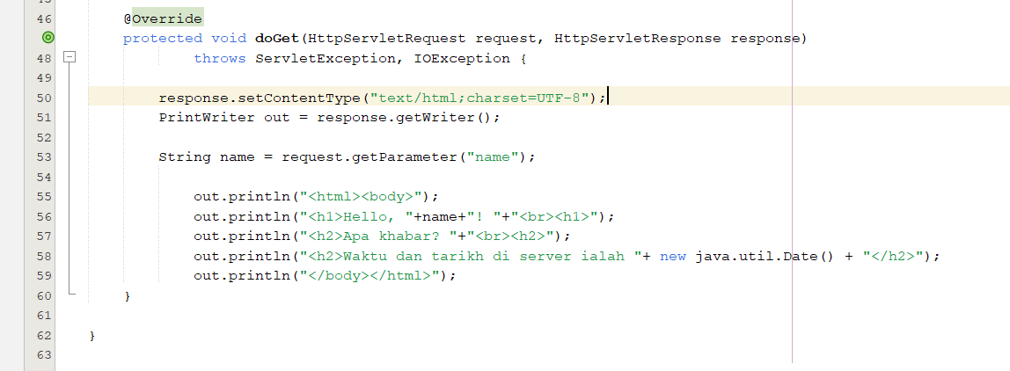

Result:
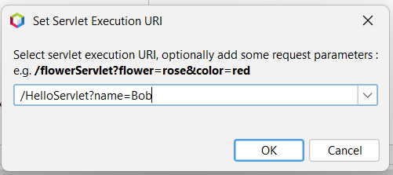
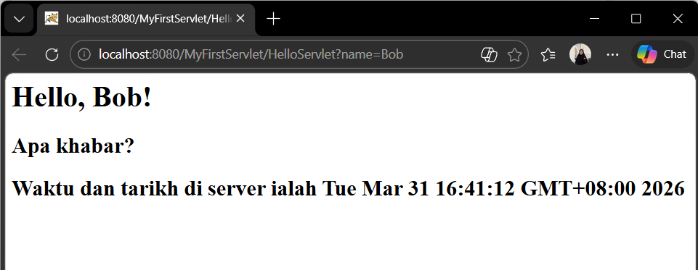
Task 7: Writing a simple JSP Program
JSP File:
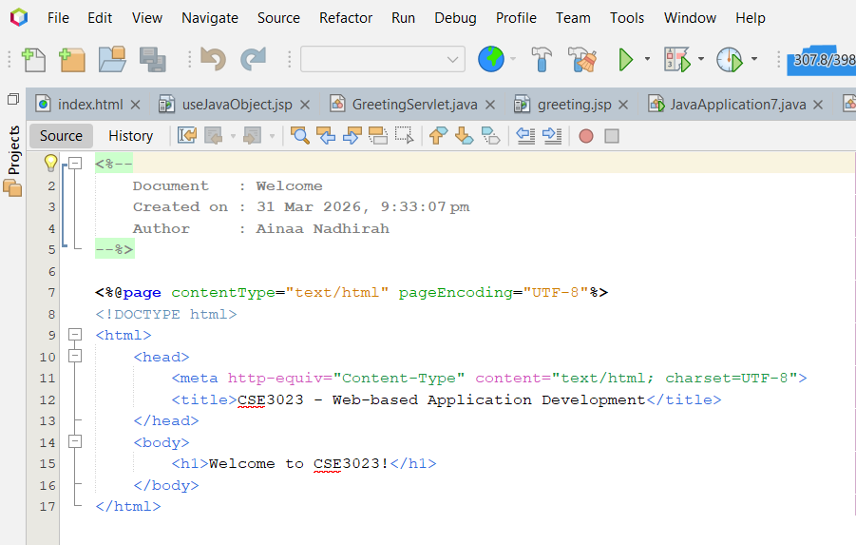

Result after running at web browser:
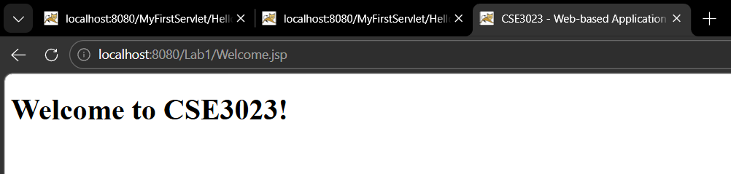

Task 8: Use Java Reference Datatype/Class Wrapper in JSP
JSP File – useJavaObject.jsp
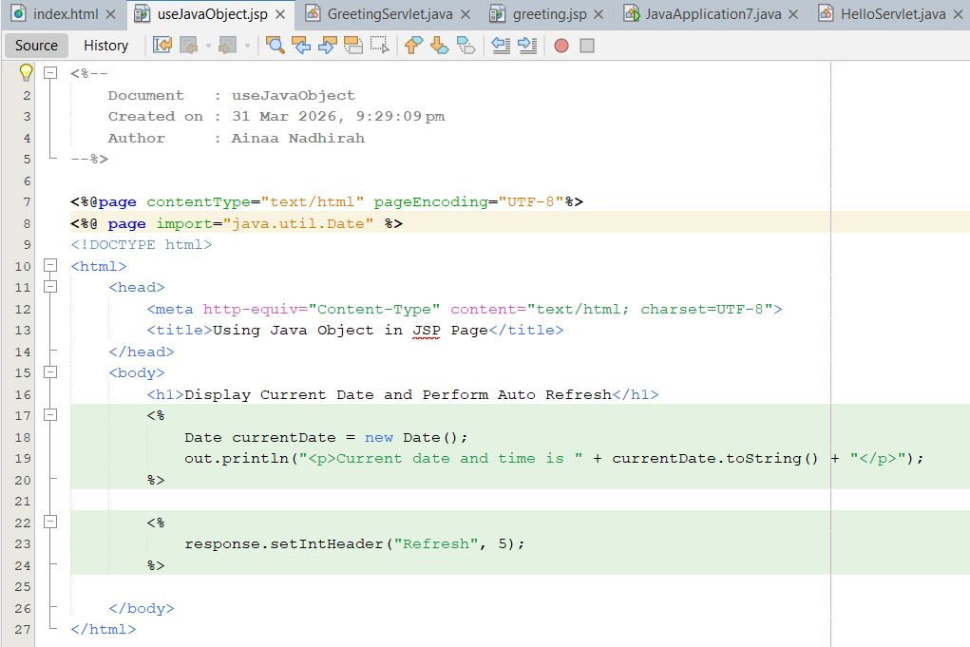

Result:
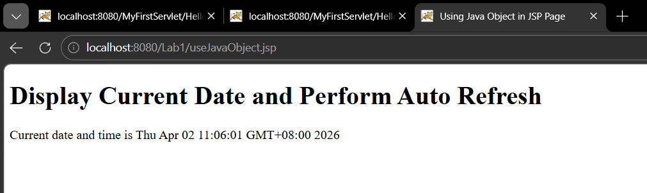
After 5 seconds:
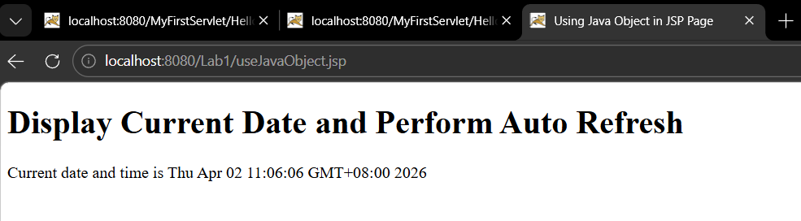

Exercise:
Code:
GreetingServlet.java
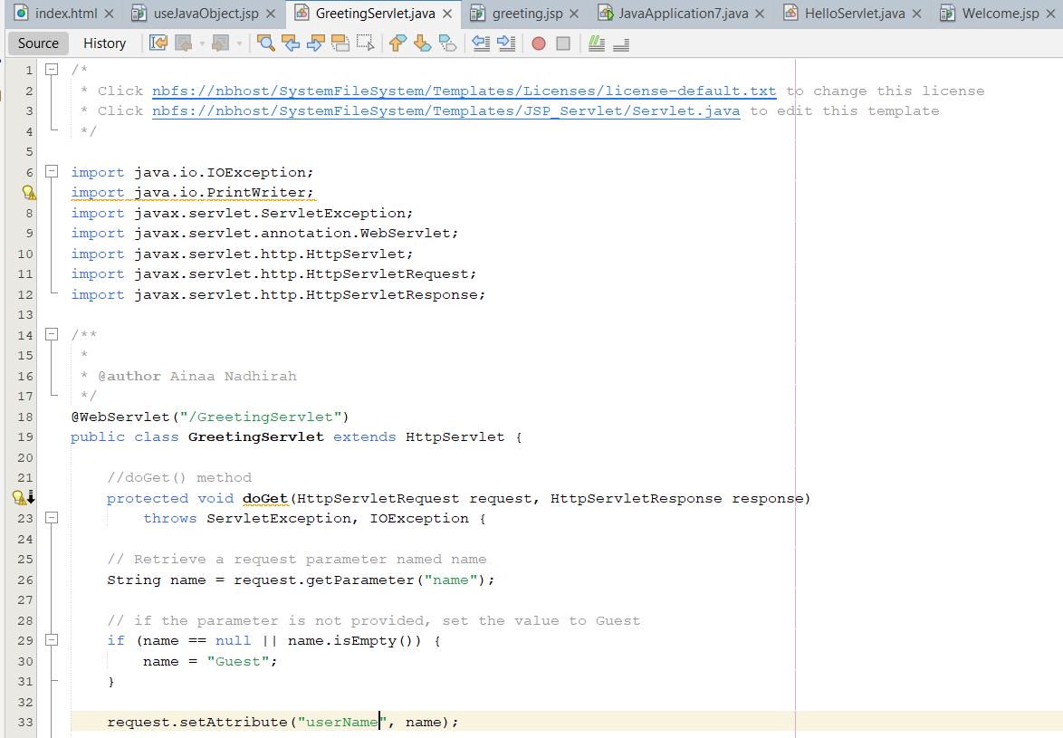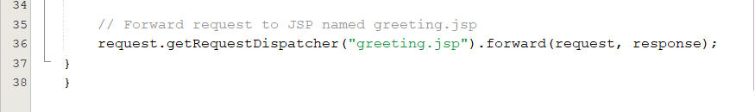

greeting.jsp
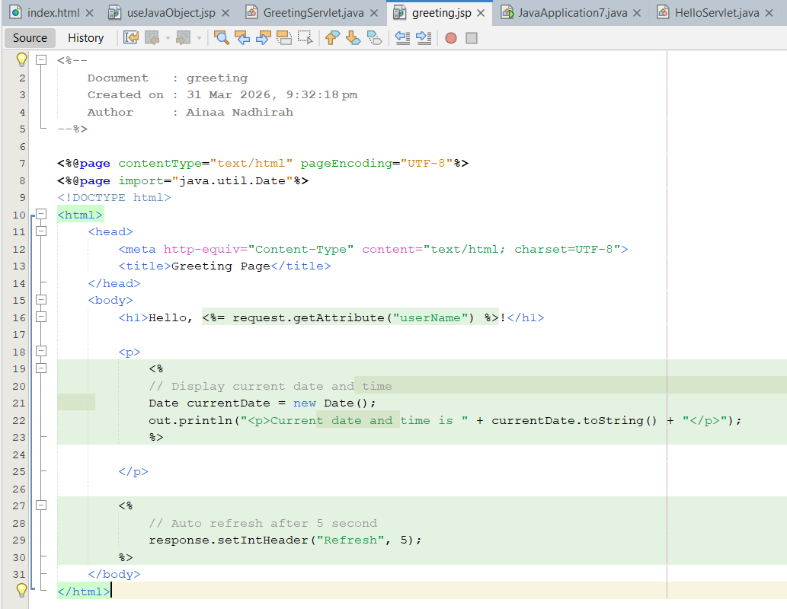

Result:
When name= Ali
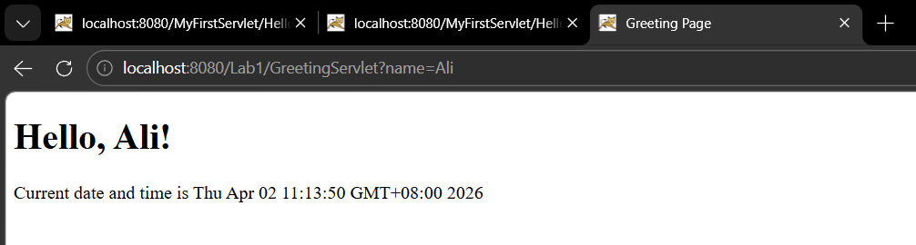

After 5 seconds:
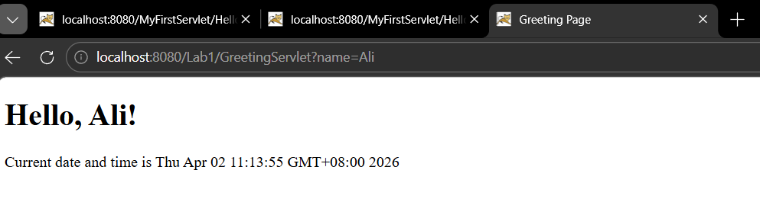

When the user didn’t enter the name:
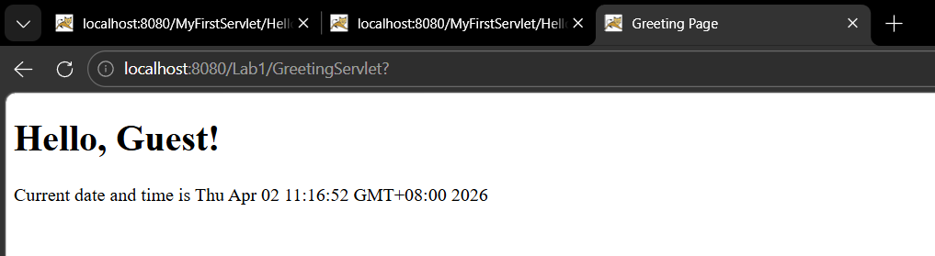

After 5 seconds:
